*Coursera-Capstone Project* Battle of Neighborhoods

*Mega City Bengaluru*

Akshata Patil

# Introduction:

Capstone Project is a process to pursue independent research on a question or problem of their choice, engage with the scholarly debates in the relevant disciplines, and - with the guidance produce a substantial paper that reflects a deep understanding of the topic. Project is of two week assignment where first part involved presenting the idea for the project, problem statement, details and methods of data to be used in project. Second part involved analysis and presenting data (coding) to prove the objective of the project along with documenting the report of analysis. Grading is based on peer-graded evaluation.

# Background:

Bangalore (Bengaluru)!! , is the capital of the Indian state of Karnataka. It is the third most popular megacity in India, next to Mumbai and Delhi. City is referred to as the "Silicon Valley of India", ‘City of Gardens', and 'Pub Capital of India'. It plays vital role as the nation's leading information technology (IT) exporter, beauty of the city reflected in its nature, culture, life style. The city is home to a number of scenic parks, movie theater complexes, boulevards, and famous memorials and edifices. The city features an exciting nightlife with a host of exotic pubs. The diversity of the city attracts many people within the country and around the world.

# Problem:

India has mega cities like Delhi, Mumbai, Bengaluru, Hyderabad etc. All are metropolitan cities and suitable for luxurious life and yet Bengaluru being in 3rd position in the list is most demanding residential city. There are many factors considered when choosing the place to live in the country.

# Interest:

In this project, Bengaluru city is explored on different levels to prove **“Why Bengaluru is best place to live?”** in the country. Geography, Climate conditions, Infrastructures, Culture, Day life and Night life or Life style of the city is explored which will attract the people within country and around the world to settle their life in Bengaluru.

# Data acquisition and cleaning:

## 2.1 Data sources:

Objective of the project is to explore the city on different aspects which are considered to be factors that people look into while choosing the place to live in country. Most of the data is collected from Wikipedia, websites and Foursquare API. Below are the details of links for data collected and how the data is used in the project.

City is explored into following categories and data will be represented in terms of statistics tables and graphs to highlight the objective the project.

1. Geography : Population and Climate details
2. Infrastructure, Culture, Tourist places
3. Food, Shopping, Nightlife and Fun
4. Economy

Source – 1:

Data is collected for geographical details from following link. Geographical details include population increasing by every year and suitable weather conditions. Source data has a table which will be parsed into xml and stored into Pandas Data Frames. These data will be plotted to explain the objective of the project.

1. <https://www.yr.no/place/India/Karnataka/Bangalore/statistics.html>
2. <http://worldpopulationreview.com/world-cities/bangalore-population>

Source – 2:

Data is collected from following links and Foursquare API. This data is used to indicate Infrastructure, culture and tourist places of the city contributing to the project. Source data has a table which will be parsed into xml and stored into Pandas Data Frames.

1. <https://en.wikipedia.org/wiki/List_of_tallest_buildings_in_Bangalore>
2. <https://en.wikipedia.org/wiki/List_of_Chola_temples_in_Bangalore>

Source – 3:

Foursquare API has different categories which help to explore the city. API's are called to collect details on Food, shopping, nightlife of the city. Venues will be explored by calling API’s and resulting JSON file will be converted into data frames to store the values obtained.

Source – 4:

Economical stats of the city are collected from following link which explains career opportunities for the people. This data is used to list famous software sectors of city which 70% economy of state indicating career opportunities.

1. <https://www.karnataka.com/profile/bangalore-main-revenue-generator-karnataka>
2. <https://en.wikipedia.org/wiki/Software_Technology_Parks_of_India>

## 2.2 Data cleaning:

Data is collected by parsing the html file into text format using BeautifulSoup libraries. Focus is to collect data table required for analysis by finding table row (‘tr’) in parsed text file. Then the data is split by new line to collect the text of table row. Empty rows will be removed by applying appropriate slicing. Resulting data will be put in Data Frames on which analysis will be performed.

Foursquare API allows collecting the data by calling different API’s based on the requirement. Resulting data will be in the form of JSON which will be converted into flat file by using JSON Normalization function. As the detail is collected from FourSquare server, data will contain unwanted columns and data records will be shifted to next columns. Data cleaning is done to get required columns and values of data records in correct position to put it in Data frames for analysis.

Some of the data collected from source links is not in the format to create data frame table. This kind of data is stored in CSV format and cleaning is done at csv file level. Later this data is read from CSV file for analysis.

# Exploratory Data Analysis:

This phase involves exploring city on different categories to show why the city is proven to be best place to live in the country. City is explored into following categories and data will be represented in terms of statistics tables and graphs to highlight the objective the project.

## 3.1 Geography: Population and Climate details:

Weather is first factor that people look for their stay. Bangalore is one of the best places in the world to live in from a weather point of view. There is often no need of air conditioning or heating in winter. The temperature in Bangalore is generally cool because of its elevation of 1000 m above sea level.

As you can see in below graph, temperature of the city is less than 35 degree which makes it not too hot not too cold. Temperature stays normal in every month.

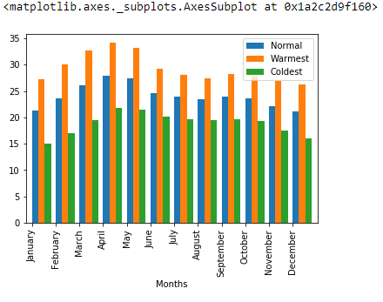

Bengaluru has an estimated population of 12.34 million in its urban area in 2017, up from 8.5 million in 2011. It is now the 24th most populous city in the world and the fastest-growing Indian metropolis behind New Delhi, growing a whopping 38% from 1991 to 2001. The city claims an area of 709 square kilometers, and with a population density marked in 2011 of over 4 thousand per square kilometer.

Below report is predicted census till 2035,

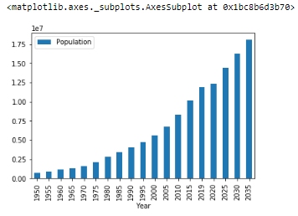

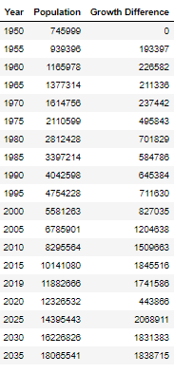

## 3.2 Infrastructure, Culture, Tourist places:

Bengaluru is the second largest metropolitan area in India, after the National Capital Region. If you are a party type, there are a lot of pubs here. go take a walk in Lalbag, eat chaats in food street near VV Puram, visit all the malls, take a visit to UB City, go to central and the British library, go to ISKCON or the Art of Living if you are the spiritual one.. there is so much to do in Bangalore, there are museums, parks, temples, mosques, churches, art galleries, Institutes, places of historical significance and what not.. More than anything talks to people around in Bangalore as they are the best both in terms of diversity and humanity. Below is the list of tall building of the city,

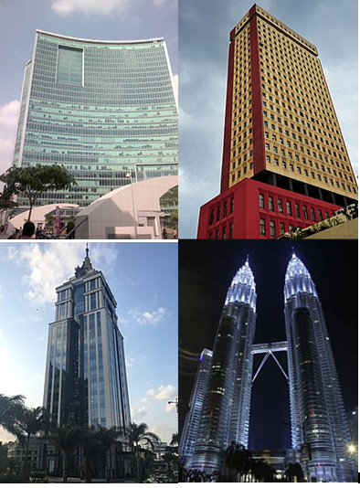

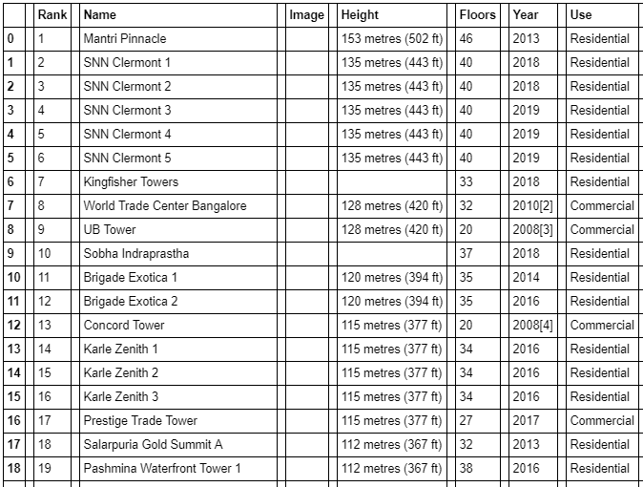

**Culture:**

The people of Bangalore are called Bangalorean and the definition permeates class, religion and language. One of the major religions of Bangalore is Hinduism. The city celebrates what is known to be Bangalore's oldest festival called "Karaga Shaktyotsava" or Bengaluru, the "Festival of Lights", transcends demographic and religious lines and is celebrated with great vigour. Dasara, a traditional celebratory hallmark of the old Kingdom of Mysore is another important festival. Other traditional Indian festivals such as Ganesh Chaturthi, Ugadi, Sankranthi, Diwali, Eid ul-Fitr, Eid ul-Azha and Christmas are also celebrated. There are many temples in Bangalore known for their temple art and cultures.

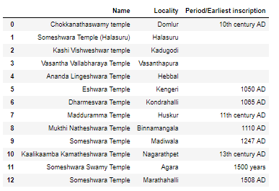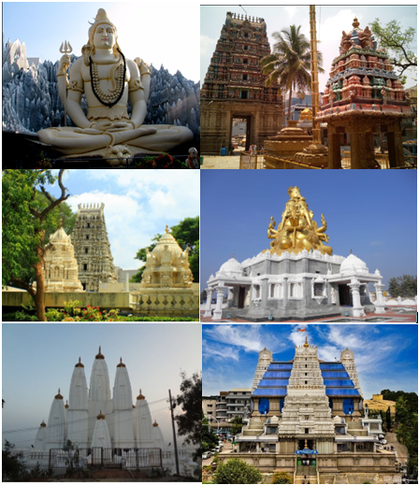

**Parks:**

Bangalore is the third-largest city in India and was once called “The Garden City” because of its many green spaces. Home to more than 12 million people it attracts of 1.5 million tourists a year. The city is filled with lush green parks, offering a respite from the stifling Indian heat. Bangalore developed a reputation as being a progressive, well-designed and green city. As you visit Bangalore, you will notice the surrounding greenery, roads lined with trees and hedges, and public parks abundant with gardens. There are many parks where you can enjoy the Garden City’s greenery, such as Lalbagh Botanical Garden, Cubbon Park, Kariappa Memorial Park and more. The parks are common places for locals to relax as well as tourists. In the early morning hours before the sun gets too hot, many people jog and exercise along the trails. The parks are well-maintained and while many of them are free, some charge a small entry fee. Below are geographical details of different parks,

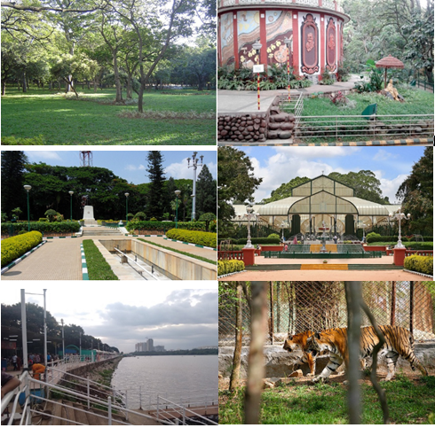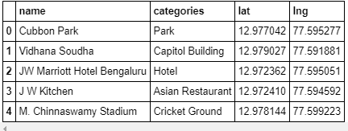

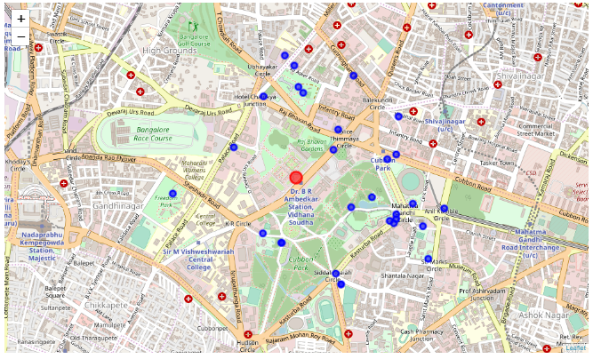

## 3.3 Food, Shopping, Nightlife and Fun

Bengaluru is famous for its swanky malls, but thriving street markets in Bangalore ensure that there are many options for shopping in Bangalore on a budget. From bustling Commercial Street to the famous stretches of MG Road and Brigade Road, these shopping destinations in Bangalore offer good bargains and easy-on-wallet deals. Packed with stalls stocking a variety of accessories, shoes, apparels, books and antiques, these street markets are perfect for indulging in some affordable retail therapy. Street shopping in Bangalore is a real joy as there is a lot of variety available and you can get a good deal if you are well adept in the art and science of bargaining. The name of MG Road rings a bell at the very moment someone mentions Bangalore and its shopping scope. A famous road stretch that runs for several kilometers through the city, MG Road is a tourist destination in itself in Bangalore. Shopping hubs such as Shrungar Shopping Complex, Bombay Swadeshi, Spencer's super market and Barton Court are located along MG Road. Bengaluru had a magnificent mix of the past and present which is well presented through its captivating museums.

Bangalore has all kinds of cousines when comes to food. Here are some of the restaurant lists and geographical coordinates.

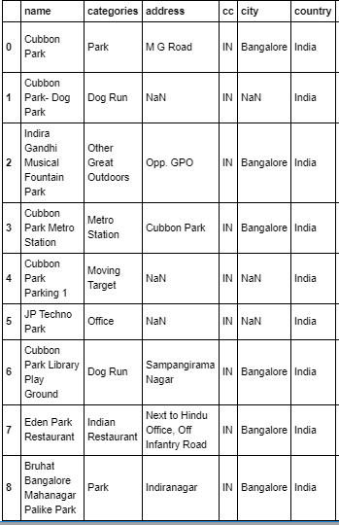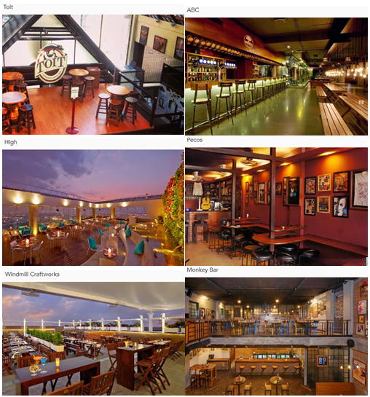

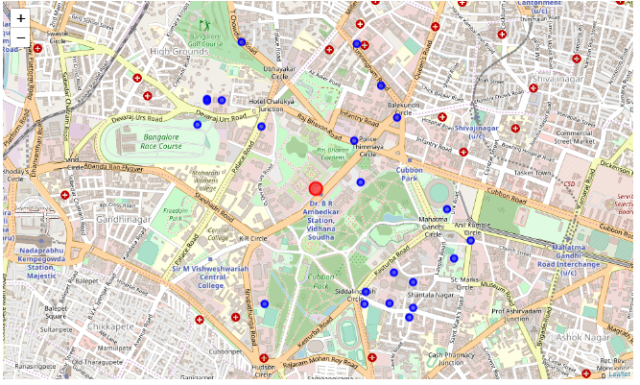

Bangalore has all kinds of cousines when comes to food. Here are some of the restaurant lists and geographical coordinates.

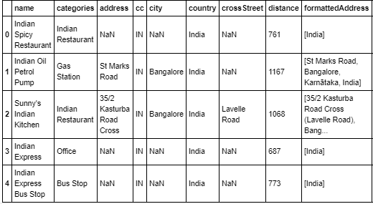 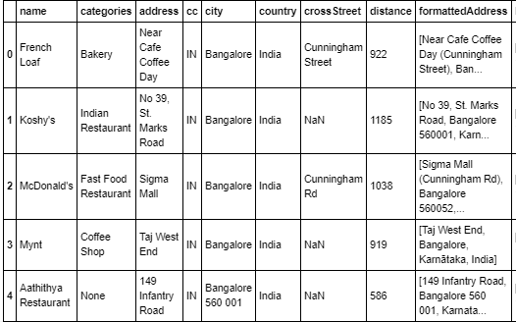

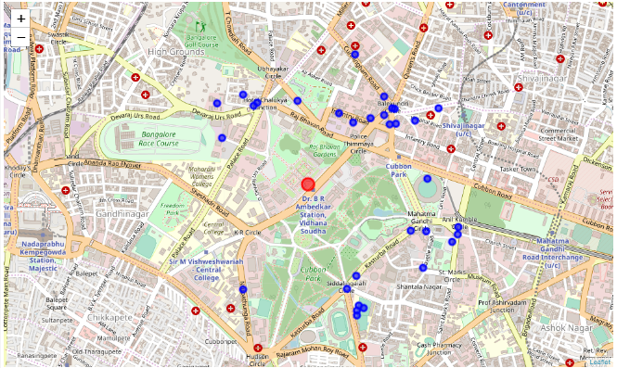

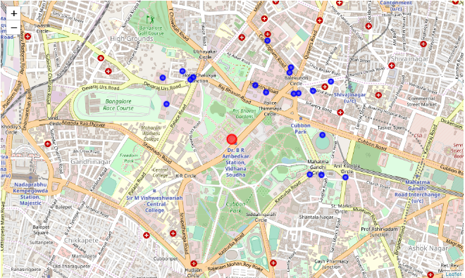

**Museums and Shopping Malls:**

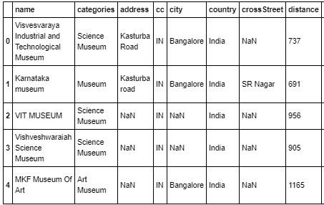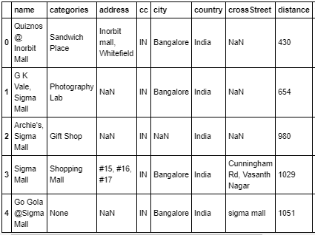

## Economy:

Bengaluru is called "Silicon Valley of India". The Economy of Bangalore is an important part of the economy of India as a whole and contributes over 87% to the Economy of the State of Karnataka, accounting for 98% of the Software Exports of the State. The establishment and success of high technology firms in Bangalore has led to the growth of Information Technology (IT) in India. Below are famous IT tech parks in Bengaluru explored using Foursquare API.

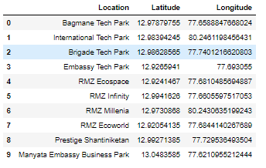

# Conclusion:

According to a global survey, Technology hub Bangalore has been ranked the best Indian city to live in. Bangalore beat Delhi, Mumbai, Chennai and Calcutta to emerge as the leading city for its quality of life. Five Indian cities make the list, which Bangalore leads for quality of living and personal safety standards, a measure of stability and crime levels. Bangalore is followed by the capital, Delhi (global rank: 143), Mumbai (144), Chennai (150) and Calcutta (151).Bangalore is home to nearly 8.5 million people. It has more than 1,500 multinational software companies, is an information technology hub and is often referred to as the Silicon Valley of India. Most of the people fall in love with the city just because of its climate.it is one of the main reasons behind people migrating from other states to the city. The weather of Bangalore has always been a key attraction for the people. The morning is bright and sunny and the nights are cooler offering you a pleasant stay. Bangalore blends together the elements of traditional and modern lifestyle and value at the same time. There are places like MG road, Brigade Road, and Commercial Street, where the youth can go and enjoy shopping and socializing. Below is the graphical representation of population of city from 1950 to projected value till 2035(projected) which is increasing yearly indicating that the city attracts people on factors explored in the project to choose ***Bengaluru as the best place to live.***

